CHAPTER-1
INTRODUCTION

  - Introduction
The topic of this project is 3D object classification. The idea is to identify objects by using their shape. A 2D image only gives two sides, but a 3D model also shows depth. This extra detail makes the object easier to study and recognize. 3D data is found in many areas like robots, VR, self-driving cars and even medical systems. This work uses the ModelNet40 dataset. It has 40 different types of objects in it. Some examples are chair, table, sofa and airplane. The 3D models are converted into point clouds, where each object is saved as a group of points in space. After this step, different methods such as PointNet++, DGCNN, GNN, Transformer and KPConv are applied for training and testing.
The aim is to compare these models and check which one gives better accuracy. The results help to understand which methods are strong and which have limits. This makes it easier to select the right approach for future tasks that need 3D shape recognition. Good results in shape classification are useful in many real situations. For example, higher accuracy can make self-driving cars safer, help doctors with better medical tools, and improve designs in industries that use 3D models. This project shows that new deep learning methods make it easier and more practical to work with 3D data.
1.2 Motivation
In many fields today, 3D models are becoming really common. 3D models let us see the whole shape of an object, including how big it is and how deep it goes, which you don’t get with flat 2D images. It helps us look at and understand real objects better. Today, it’s much easier to collect 3D data using scanners, depth cameras, and modeling tools. Sorting and classifying these shapes come in handy in fields like robotics, healthcare, navigation, and virtual reality. Older methods mostly depended on manually chosen features, which didn’t always work well when the data was noisy or incomplete. Because of this, better methods are needed that can work directly on 3D points and find useful patterns. The purpose of this project is to test and compare different techniques for classifying 3D objects using the ModelNet40 dataset. The main goal is to see how well these methods can learn both the overall structure and the small details of objects, so classification becomes more reliable in real world tasks.

1.3 Problem Definition:
3D object classification is harder than 2D image work. A 2D picture has pixels in a grid. A 3D model is just points in space. These points have no order, so it is tough to catch both details and overall shape. Normal image methods do not fit well here. The project uses the ModelNet40 dataset. It has 40 object classes like chair, table, sofa, and airplane. Each model is changed into a point cloud. Then different methods like PointNet++, DGCNN, GNN, Transformer, and KPConv are tested. The goal is to see which model gives better accuracy.
The main challenges this project attempts to solve are:
- Unordered points : no fixed grid like images.
- Shape change : objects in one class may look very different.
- Rotation and scale : objects may appear in many angles or sizes.
- Missing data : point clouds can be noisy or incomplete.
- High cost : training deep models takes more memory and time.
- Generalization : models must also work on new data.
Good results in this project can help real tasks. Robots, cars, and VR systems need better shape recognition. Strong models also save time in design and can support medical tools.
1.4 Objectives:
- Prepare the dataset: The 3D models from the ModelNet40 dataset are first converted into point clouds. These point clouds are then normalized to make them uniform in scale and position. Finally, the data is divided into training and testing sets for experiments.
- Apply multiple methods: Different deep learning models such as PointNet++, DGCNN, GNN, Transformer, and KPConv are used. Each of these methods is chosen because it can handle irregular 3D data. This allows a fair comparison of how they perform on the same dataset.
- Train and test models: The prepared dataset is given as input to the models for training. Each model is trained to learn the shape features of objects. After training, testing is done to measure their accuracy on unseen data.
- Compare performance: The models are compared based on accuracy, speed, and resource use. Training time and memory needs are also considered. This makes it easier to see which method works better.
- Looking at strong and weak points: Some models may handle rotation and scale changes better. Others may work well even with missing or noisy data. The differences are noted to study the strong and weak sides of each method.
- Identify the best model: After comparing results, the most reliable model is selected. This model should perform well across all categories. It is also expected to give stable results in real use.
- Provide future scope: The findings can help improve robotics and self-driving cars. They can also support better design tools and medical systems. This makes the study useful beyond just academic research.
1.5 Scope
This project is about classifying 3D objects by shape. It looks at how 3D data, stored as point clouds, can be used for recognition. Unlike images, 3D models have depth, which makes them more useful for finding the actual form of an object. The work is limited to the ModelNet40 dataset. It has 40 categories such as chair, table, sofa, airplane and others. These models are turned into point clouds and then used for training and testing.
The project uses a few selected methods. PointNet++, DGCNN, GNN, Transformer and KPConv are tested. No new models are built; the focus is only on applying these known methods and comparing how they work. Performance is also part of the scope. The models are checked for accuracy, training time, and how they deal with problems like noisy or rotated data. From this, it is possible to see which method is more useful in practice.
The scope also extends to real uses. 3D classification can help in robotics, self-driving cars, VR/AR, and medical tools. This makes the project useful not only for study but also for future applications.

CHAPTER-2
LITERATURE SURVEY

2.1 Literature Survey
The authors of paper [1] proposed MorphoSkel3D, a method for skeletonizing 3D point clouds to guide sampling for object classification and retrieval. The approach reduces redundancy while preserving global and local structure. Experiments on ModelNet and ShapeNet datasets showed improved classification and retrieval compared to random or uniform sampling. The method is lightweight, training-free, and works across different datasets.
The authors of paper [2] developed a method for object classification using neuromorphic proprioceptive and tactile signals from a soft robotic hand. A spiking neural network processes sensory data collected during active exploration. The model achieved high classification accuracy, especially when visual information was limited, demonstrating the value of sensor fusion for real-world object recognition.
The authors of paper [3] provided a comprehensive review of deep learning techniques for 3D point cloud classification and semantic segmentation. The paper discusses voxel-based, point-based, multi-view, and hybrid methods, highlighting challenges such as irregularity, noise, and scalability. Datasets like ModelNet, ShapeNet, and ScanObjectNN were reviewed, and future research directions include efficiency, robustness, and self-supervised learning.
The authors of paper [4] introduced Pix4Point, a framework that transfers knowledge from 2D pretrained Transformers to 3D point cloud tasks. Using a tokenizer-decoder design, the model adapts image representations for point cloud classification and segmentation. Tests on ScanObjectNN and ShapeNet showed improved accuracy and efficiency compared to training from scratch.
The authors of paper [5] presented GTNet, a graph Transformer network for 3D point cloud classification and segmentation. The model combines graph-based local aggregation with global attention to capture detailed and large-scale features. Evaluations on ModelNet40 and ScanObjectNN showed competitive performance, highlighting the benefits of combining graph learning with Transformers.
The authors of paper [6] proposed CDFormer, a collect-and-distribute Transformer for 3D point cloud analysis. The method gathers global context into proxy points using self-attention and redistributes it to local points with cross-attention. Adding context-aware positional encoding improved feature learning. Experiments on ModelNet40 and ScanObjectNN demonstrated higher classification and segmentation accuracy compared to baseline models.
The authors of paper [7] developed 3DCTN, a 3D convolution-Transformer network for point cloud classification. Convolution layers capture local details while Transformer blocks extract global context. Multi-scale aggregation improves feature representation. Tests on ModelNet40 showed better accuracy than networks using only convolution or only Transformer blocks, balancing performance and computation.
The authors of paper [8] proposed a mesh-based deep neural network for 3D shape classification. Structural and geometric features are extracted from mesh data and fed into a deep network. Experiments on benchmark datasets achieved competitive accuracy with point- and voxel-based methods, demonstrating the value of using mesh information when available.
The authors of paper [9] provided a survey of 3D point cloud classification methods, covering voxel-based, point-based, multi-view, and hybrid approaches. They discussed datasets like ModelNet, ShapeNet, and S3DIS, as well as common challenges such as efficiency, robustness, and limited data. The survey also suggests future research directions.
The authors of paper [10] introduced SN-Graph, a minimalist 3D object representation using sphere-node graphs from signed distance fields. The method preserves key shape information while being lightweight. Evaluations on ModelNet40 showed strong classification accuracy even with rotated or low-resolution objects, proving that compact representations can still perform well.
2.2 Summary Of Literature Survey
Researchers have proposed many approaches to classify and analyze 3D point clouds. Some methods focus on reducing unnecessary data while keeping important features, like MorphoSkel3D, which simplifies point clouds through skeletonization. Others, such as Pix4Point, adapt knowledge from 2D pretrained models to 3D tasks. Models combining graph networks and Transformers, like GTNet and CDFormer, are used to capture both local details and overall structure. Convolution-Transformer networks like 3DCTN mix local feature extraction with global context. In addition, mesh-based methods and techniques using tactile or movement sensors have been explored to improve accuracy when point cloud information alone is limited.
3D point clouds can be tricky to work with because the data is often messy or incomplete, and datasets are sometimes small. Some methods use voxels, others look at each point individually, and some mix different ways together. These models need a lot of computing power. using different techniques together, like graphs, Transformers, convolutions, or mesh features, gives better results. This also helps the models work well in real tasks.
2.3 Related Works
Table 2.3.1 Related Works
Sl No | Title | Author(s) | Year | Common Challenges Identified
1 | Deep Learning for 3D Point Cloud Enhancement: A Survey | Quan | 2024 | Addressing sparsity, noise, and incompleteness in raw point cloud data.
2 | A Survey of Label-Efficient Deep Learning for 3D Point Clouds | Xiao | 2024 | Reducing label dependency; enhancing model efficiency with limited labelled data.
3 | Depth Voting: A Few-Shot Point Cloud Classification Model Incorporating a Projection-Based Approach | Zhu | 2024 | Handling missing points in 3D data; few-shot learning challenges.
4 | Advancements in Point Cloud-Based 3D Defect Detection | Rani | 2024 | Detecting defects in industrial applications; segmentation complexities.
5 | Interpretable Point Cloud Classification Using Multiple Instance Learning | De Vries | 2024 | Enhancing model interpretability; trust and usability in safety-critical applications.
6 | Risk-Optimized Outlier Removal for Robust 3D Point Cloud Classification | Li | 2024 | Managing various forms of noise; ensuring robust classification.
7 | Enhancing Explainability of Deep Learning Models for Point Cloud Classification | Matrone | 2024 | Improving model explainability; application in indoor and urban outdoor datasets.
8 | Low-Density 3D Point Cloud Classification | Jmaa | 2024 | Classifying sparse point clouds; challenges in real-world scenarios.
9 | A Comprehensive Review of Deep Learning Techniques for 3D Point Cloud Classification and Semantic Segmentation | Sarker | 2024 | Addressing irregular, noisy, and large-scale data issues.
10 | A Survey of Deep Learning-Driven 3D Object Detection | Zhang | 2025 | Integrating multimodal sensor data; detection complexities.
11 | Advancements in Deep Learning for Point Cloud Processing | Zhou | 2025 | Development of deep learning models; processing challenges in point cloud data.
12 | Breaking Barriers in 3D Point Cloud Data Processing | Wang | 2025 | Overcoming traditional algorithm limitations; processing large-scale data.
13 | Review of Point Cloud Segmentation for Understanding 3D Indoor Scenes | Sun | 2024 | Segmenting indoor scenes; dataset and method diversity.
14 | Deep Learning-Based 3D Point Cloud Classification for Urban Planning | Liu | 2024 | Classifying urban structures; handling complex urban datasets.
15 | 3D Point Cloud Classification Using Hybrid CNN-RNN Architectures | Kim | 2023 | Combining CNN and RNN architectures; addressing sequential dependencies.
16 | Multi-Scale Feature Learning for 3D Point Cloud Classification | Zhang | 2023 | Capturing multi-scale features; ensuring computational efficiency.
17 | Graph Neural Networks for 3D Point Cloud Classification | Li | 2022 | Implementing graph neural networks; handling irregular data structures.
18 | Self-Supervised Learning for 3D Point Cloud Classification | Wang | 2022 | Utilizing self-supervised learning techniques; reducing labelled data dependency.
19 | Attention Mechanisms in 3D Point Cloud Classification | Zhang | 2021 | Applying attention mechanisms; focusing on relevant features.
20 | Transformer-Based Models for 3D Point Cloud Classification | Liu | 2021 | Adapting transformer models; processing large-scale point cloud data.

CHAPTER-3
DATASET

3.1 Dataset Review
ModelNet40 is a dataset mostly used in computer vision for 3D object recognition. It was made so that researchers have a standard collection of 3D models and can compare results fairly. The dataset has 40 categories of objects. Some examples are chair, sofa, bed, table, airplane, lamp and many more. Each category has a good number of samples, so it can be used for both training and testing.
The models are given in .off format. This format basically shows an object by marking points and connecting them with faces. Thanks to this, the model can be converted and used for different purposes. For example:
- Some people sample points from it and make point clouds.
- Others turn it into voxel shapes (3D grids).
- Some even capture images of the model from different sides.
This flexibility is one reason why ModelNet40 is so common in 3D research. The dataset has a little more than 12,000 models. Out of these, about 9,800 are for training and nearly 2,400 for testing. That amount is large enough for deep learning, which usually needs a lot of data. One more thing is that the categories are clear, so it is easy to tell which object belongs to which class.
But it also has some problems. The objects are computer-made CAD models, so they look too clean and smooth. Real-world 3D scans are not like that — they often have noise, broken edges or missing parts. Because of this, a model trained only on ModelNet40 may not work as well in real cases. Another issue is that all the models are kept in the same fixed direction, while in real life objects can appear in many random poses.
Even with these drawbacks, ModelNet40 is still very important. Over the years, many 3D recognition studies have started with ModelNet40. It is still chosen by students and researchers since the dataset is simple, has enough samples, and is not difficult to handle. This makes it a standard choice in 3D computer vision.

3.2 ModelNet40 Image Dataset


Fig 3.2 Dataset Of ModelNet40

- Dataset Name: ModelNet40
- Source: Princeton ModelNet Project – Princeton University’s Vision & Robotics Lab
- Data Type: 3D CAD models of real-world objects
- Categories: 40 object classes (e.g., chair, table, sofa, airplane, car, lamp, plant)
- Dataset Size: Total Models: 12,311
  - Train: 9,843 models
  - Test: 2,468 models
- Resolution & Format:
- Models normalized to fit within a unit sphere
- Common formats: .off, .ply (can be converted to point clouds)
- Uniform point sampling from object surfaces
- Balanced Classes: Each category has a similar number of models for fair training and testing.
- Train/Test Split:
- Train: 80%
- Test: 20%
- Metadata & Labels: Each model includes category label and geometric mesh data.
3.3 Dataset Classes
- Airplane
28. Radio
29. Range hood
30. Sink
31. Sofa
32. Stairs
33. Stool
34. Table
35. Tent
36. Toilet
37. Tv stand
38. Vase
39. Wardrobe
40. Xbox
- Bathtub
- Bed
- Bench
- Bookshelf
- Bottle
- Bowl
- Car
- Chair
- Cone
- Cup
- Curtain
- Desk
- Door
- Dresser
- Flower pot
- Glass box
- Guitar
- Keyboard
- Lamp
- Laptop
- Mantel
- Monitor
- Night stand
- Person
- Piano
- Plant
3.4 Data samples for each classes
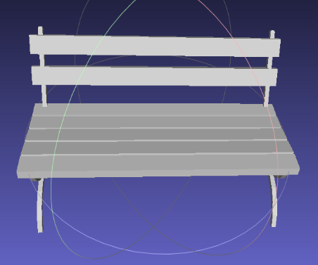
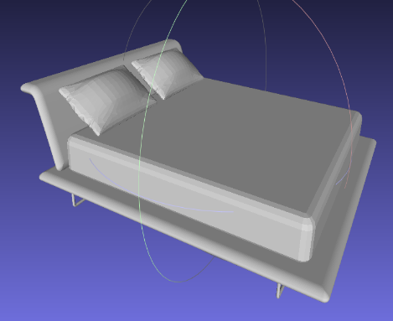
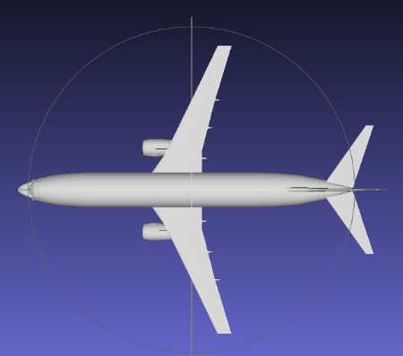

Bench

Bed
Airplane
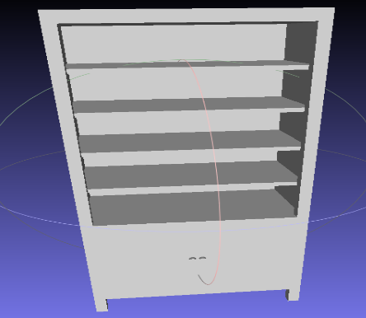
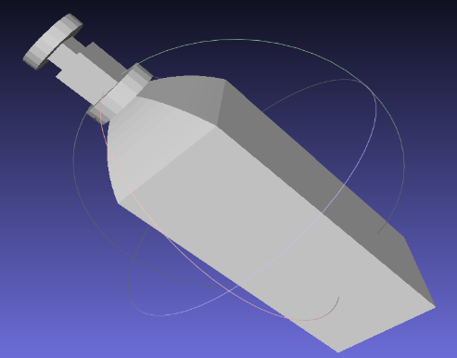
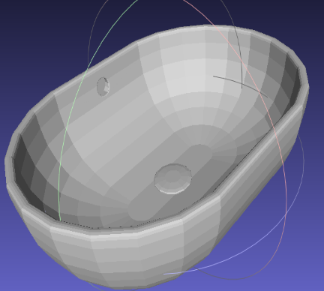

Bowl
Bottle
Bookshelf

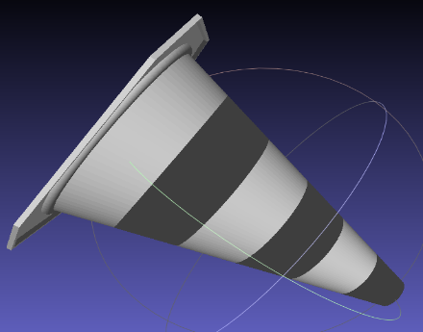
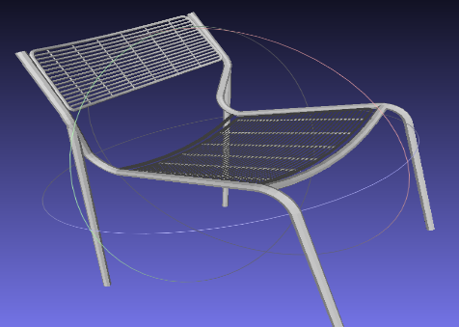
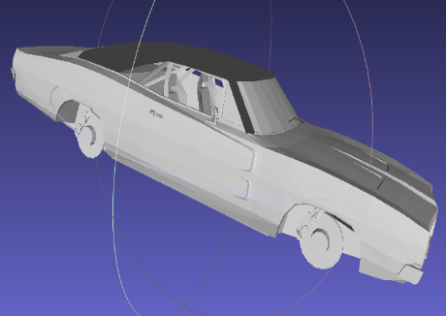

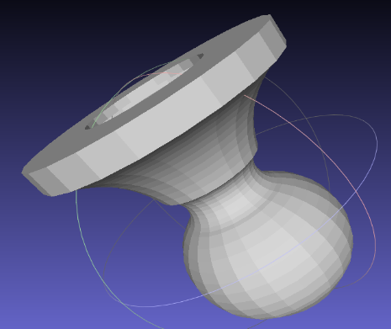
Cone
Chair
Car
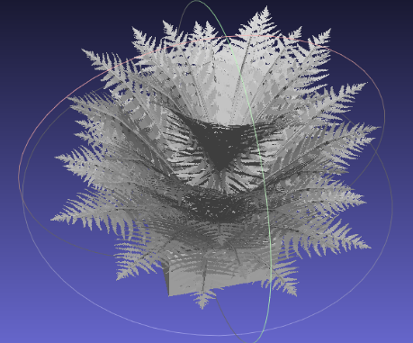
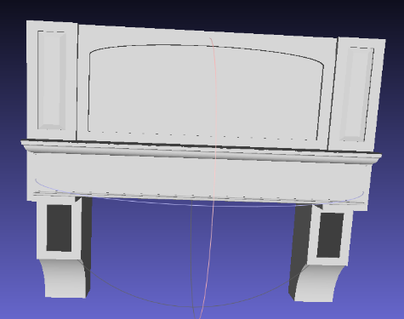

Fig 3.4 Data Samples For Each Classes
Vase
Plant
Mantel

CHAPTER- 4
PROPOSED SYSTEM

4.1 EXISTING SYSTEM
In older systems for 3D object classification, the common idea was to turn 3D models into 2D images. A shape was shown from different angles, and then image models were used for recognition. This worked because image networks were already strong, but it also dropped some depth and shape details. Important information about inside parts of the object could not be seen in 2D. Later, voxel-based methods were used. A 3D model was cut into a grid made of small cubes called voxels. Then 3D convolutional neural networks were applied. This gave more detail than 2D images, but the cost was very high. Large voxel grids needed huge memory and slow training. This made them less practical for big datasets.
Another system type worked directly on point clouds. Instead of grids or images, each object was stored as points in 3D space. Models like PointNet started this approach. These were faster and used less memory. But they had trouble with local structures because points were treated separately and the network could miss small details between nearby points. Graph-based models came after that. They treated each point like a node and built edges to connect neighbors. This allowed the model to see both close features and full shape features together. Dynamic Graph CNN (DGCNN) is one example. These models often improved accuracy, but they also needed more computation for building graphs and careful tuning of parameters.
Recently, Transformers have been tested for point clouds. They use attention layers to capture relations across all points. This is good for long-distance features and complex shapes. These models showed high accuracy but needed big training data and more computing power. They also need extra changes before they can work well on 3D data. Without those changes, the results are not stable. Training is also heavy and slow for large datasets. The systems so far have moved one step at a time. First 2D images, then voxels, later point-based, graph-based, and now Transformer models. Each step fixed something but also added a new issue. Some methods lose details, some run very slow, and some need powerful hardware. The search is still going on to find a model that is simple, fast, and still accurate for real 3D work.
DISADVANTAGES:
- Loss of detail in some methods: Projection-based systems convert 3D models into 2D images. This step removes depth and inside information of the object. As a result, the model may confuse objects that look similar in 2D.
- It reduces accuracy in fine-grained classification tasks: High memory and computation. Voxel-based approaches divide the object into small cubes. Large grids require a huge amount of memory and processing power. Training becomes slow and sometimes not practical for big datasets. This makes such methods hard to use in real-time applications.
- Weak local feature learning: Point-based models like PointNet treat points as independent. They can miss relationships between nearby points. This limits the ability to capture local patterns or small parts of objects. Accuracy drops for shapes with fine details.
- Need for heavy resources in advanced models: Graph and Transformer methods give strong performance. But they need more computation, bigger datasets, and fine-tuning. These requirements make them hard to train on normal systems. This limits their use in small labs or lightweight devices.
4.2 PROPOSED SYSTEM
The proposed system is made for classifying 3D objects by working on point cloud data. Instead of turning shapes into 2D views or voxel grids, the method uses raw points directly. In this method, depth is kept and shape details are also kept. These are the parts that usually get lost in other formats. The dataset used is ModelNet40. It has 40 classes such as chair, table, sofa, and airplane. Each object is saved as points in 3D space. Before training, the point clouds are normalized so that all objects are kept at the same scale and size.
In this system, several deep learning models are tested. These include PointNet++, DGCNN, GNN, Transformer, and KPConv. Each of these has its own way of learning from the 3D points. Training them on the same dataset makes it possible to compare their performance fairly. The system does not only measure accuracy. It also records memory use, training time, and processing speed. Some models can be fast but not as correct, while others may give better accuracy but take more time and resources. These differences are clearly noted. At the end, the proposed system gives a clear view of which model is better for 3D object recognition. The outcomes can be applied in areas such as robotics, self-driving vehicles, VR/AR, and medical devices. Because of this, the system is important not only for study but also for real use.

ADVANTAGES:
- Preserves 3D details: The system works on raw point clouds without converting into 2D or voxel grids. This keeps depth and fine structure safe for learning. No important features are lost in the early steps. Models can use both global and local information.
- Fair model comparison: Several deep learning models are tested on the same dataset. PointNet++, DGCNN, GNN, Transformer, and KPConv are included. This makes the results more reliable and unbiased. Strengths and limits of each method are clearly seen.
- Covers efficiency and accuracy: The system does not only check accuracy of classification. It also records memory, speed, and training cost. This helps to see which model is practical in real use. Trade-offs between speed and performance are highlighted.
- Useful for many applications: The results can support robotics, VR/AR, and self-driving cars. Medical tools also benefit from better 3D recognition. Strong models improve safety and automation in daily tasks. The scope goes beyond only academic research.
- Simple and direct design: The system avoids heavy voxel grids or 2D projections. It works on point data directly, which is easier to handle. Preprocessing is kept minimal and clear. This reduces extra steps and makes experiments faster.
4.3 Tools And Technologies
4.3.1 Hardware Requirements:
- Processor: Intel i5, i7, or AMD Ryzen 5/7 is suggested. These have more cores. Bigger datasets run better on them. Training is also faster than i3.Training is faster and smoother compared to i3
- RAM: 8 GB can run training, but sometimes it feels slow. 16 GB makes it better and smoother. More RAM also helps when using large datasets.
- Hard Disk: 500 GB storage is safe. SSD is faster than HDD for loading files. Space is used for datasets, code, and results. More space is better for backups.
- Graphics: NVIDIA GPU like GTX or RTX with 4 GB VRAM or more. GPU makes training much faster. Needed for large point cloud models. Without GPU, training is very slow.
- Other: Cooling is needed for long training runs. Internet is required to download datasets and libraries. Normal keyboard, mouse, and monitor are enough.
4.3.2 Software Requirements:
1. Operating System: Windows 10 or Linux . Both can run. Linux is better when GPU is used.
2. Programming Language: Python 3.7 or above. Needed for code. Works with most libraries.
3. Libraries:
- PyTorch: For training and testing deep learning models.
- TensorFlow: Another option for model training and evaluation.
- NumPy: For arrays and number operations.
- SciPy: For scientific and math functions.
- Matplotlib: For graphs and simple plots.
4. Open3D: For point cloud data and 3D display.
5. IDE/Editor: Google collab, Jupyter Notebook, PyCharm, or VS Code. Any editor is fine for writing and testing code.
6. Other Tools: CUDA and cuDNN if GPU is used. Needed to make training faster on NVIDIA cards.
4.3.3 Modules Analysis
1. PointSampler:
PointSampler is used to reduce the number of points in a 3D point cloud. A point cloud can have thousands of points. Using all makes training slow. PointSampler picks a fixed number like 1024 or 2048. The main shape is kept, but data size is smaller. Training runs faster and memory use is less. PointSampler ensures all objects have the same number of points before entering the model. Without this step, inputs would be uneven and could break the training process. It is a simple but effective method to balance accuracy and speed. The system does not lose much shape detail if points are sampled properly. This module is applied every time data is loaded.

2. Normalize:
Normalize is used to bring all point clouds into a common scale and position. Objects from datasets may appear larger, smaller, or shifted in space. Normalization shifts the object to the center. Then it scales it down to fit inside a unit sphere. This keeps all objects in the same space. This step removes variations caused by size and placement. It helps the model focus on the true geometry instead of being distracted by different scales. Normalize also avoids bias when comparing categories like chair and table. Without normalization, two same objects could look different just because one is shifted or zoomed. This step makes the dataset clean and consistent. It is a basic but powerful preprocessing stage.
3. ToTensor:
ToTensor is a conversion step that changes NumPy arrays into tensors. PyTorch works only with tensors. So, data must be changed into tensor form. This step makes the input valid. Tensors also speed up work on CPU and GPU. This helps the model to train and test quickly. ToTensor is not a complex step, but without it, the model would not accept the input data. It bridges the gap between preprocessing and deep learning. This module is simple, lightweight, and always applied at the end of preprocessing.
4. ModelNet40 Dataset Loader:
The dataset loader is responsible for reading files from the ModelNet40 dataset. ModelNet40 dataset has 40 categories. Examples include chair, table, airplane, and sofa. Each category has many 3D models. The loader applies preprocessing steps like PointSampler, Normalize, and ToTensor automatically. It organizes the data into training and testing sets. This saves time because the user does not need to load and prepare files manually. The loader also prepares data in batches, which makes training easier and smoother. It helps the system handle thousands of objects without memory issues. By combining preprocessing in one place, the loader keeps the pipeline clean. It is an important backbone for running experiments on ModelNet40.
5. PointNet++:
PointNet++ is a neural network model designed for point clouds. It extends the original PointNet by learning features in a hierarchical way. It divides the points into groups, extracts local features, and then combines them into global features. This helps in learning both fine details and overall shape. PointNet++ is simple but effective for classification. In the project, it is used as one of the baseline models. The results from PointNet++ help compare performance with more advanced models. PointNet++ is lighter on resources than some other models. This makes it easier to run, though sometimes less accurate. It is still a strong model for 3D recognition tasks.
6. DGCNN:
DGCNN stands for Dynamic Graph CNN. It builds a graph structure from point clouds by finding nearest neighbors for each point. This graph changes at each layer, which is why it is called “dynamic.” EdgeConv operations are used to extract features from connections between points. This makes the model very good at learning local geometric details. In the project, DGCNN is tested for classification accuracy. It often performs better than PointNet++ but takes more resources. Updating the graph at every layer makes it slower than some other models. Still, it is very powerful when high accuracy is needed.
7. GNN:
The GNN module represents the point cloud as a graph. In GNN, each point is a node. Edges connect it to nearby points. At every step, nodes update features by learning from neighbors. This spreads information across the graph. This process captures both local and global structure. In the project, the GNN is applied to learn complex patterns in 3D objects. It works well with irregular data. However, graph construction takes extra time and memory. GNNs are flexible but often harder to train compared to simpler models. They can still achieve strong results if tuned correctly.
8. Transformer:
The Transformer model uses attention to process point clouds. Instead of fixed neighborhoods, it allows the network to focus on the most important points anywhere in the object. This helps capture long-range relations between parts of the shape. The encoder embeds points and passes them through multiple attention layers. This gives a global view of the object while still keeping local detail. In the project, the Transformer is tested for classification tasks. It is often accurate but needs more memory and GPU power. Transformers are becoming popular because of their flexibility. However, they are harder to train compared to other models.

9. KPConv:
KPConv stands for Kernel Point Convolution. It applies convolution directly on irregular point sets by placing kernel points in space. These kernels move during training and learn geometric features. Unlike voxel-based methods, KPConv works directly with raw points. This allows it to capture local shape details very well. In the project, KPConv is tested as a powerful classification model. It handles both small features and full object structures. However, it needs strong hardware to run efficiently. It is more complex than PointNet++ but can achieve higher accuracy. KPConv is often used when precision is more important than speed.

CHAPTER-5
SYSTEM DESIGN

5.1 Architecture Diagrams:
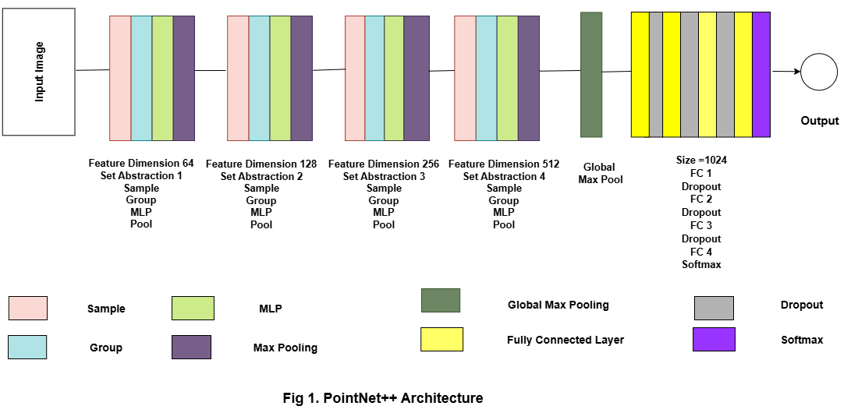
5.1.1 PoineNet++ Architecture

Fig 5.1.1 PointNet++ Architecture

- Input
Start with a point cloud: N points with (x, y, z) (optionally normal).
Typical input size is 1024 points per object in many setups.
- Set Abstraction (SA) – idea
Each SA block finds a smaller set of “representative” points and computes a feature for each representative by looking at its local neighbours.
Repeating SA blocks builds a hierarchy: small local features → larger context → global feature.
- SA1 — Sample
Pick a subset of points (sampling). Common method: farthest-point sampling (FPS).
This reduces N to N₁ (example: 1024 → 512). The picked points become local region centers.
- SA1 — Group
For each sampled center, collect nearby points (by radius or k-NN).
This gives a local patch (e.g., 32 neighbours) around each center.
- SA1 — MLP on grouped points
For each local patch, subtract the center coordinates (use relative positions) and pass the patch points through a shared MLP (pointwise conv).
This produces per-point features inside the patch (same MLP weights are shared across patches).
- SA1 — Pool (max)
Apply a symmetric pooling (usually max) over the patch to get one feature vector per center.
Result: N₁ feature vectors with feature dimension = 64 (as in the diagram).
- Repeat SA blocks (SA2, SA3, SA4)
Each subsequent SA block repeats Sample → Group → MLP → Pool, but with larger receptive field and higher feature dimension (128, 256, 512).
Each block samples fewer centers (N₂ < N₁ < …) and captures more global context.
- Global Max Pool
After the last SA block, pool across all remaining points to get a single global descriptor.
Global max pooling makes the descriptor invariant to point order and captures the strongest activations across the object. The diagram shows a global vector of size 1024.
- Fully Connected
The global vector goes into a stack of fully connected layers with activations and dropout.
These layers (FC → dropout → FC → …) map the 1024-dim descriptor to class scores.
- Softmax / Output
Final layer produces logits for each class. A SoftMax (during inference or CrossEntropyLoss during training) gives class probabilities.
The predicted class is the one with highest probability.
Discussion: I tried adding an extra set abstraction layer to PointNet++ and saw that it helped the accuracy improve over time. With just one extra layer, the model started at around 73% in the 10th epoch and went up gradually to about 79% by the 40th epoch, but then it dropped a little to 79.36% at epoch 50. When I added five extra layers, the accuracy actually dropped to around 76% at epoch 50. This shows that while one extra layer helps the model learn features better, adding too many layers can make training harder and can lower performance. For this dataset, it looks like just one extra layer gives the best results.
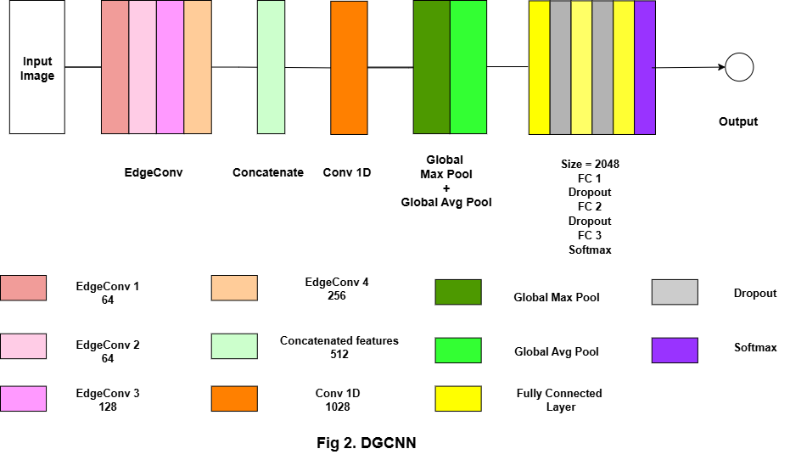
5.1.2 DGCNN Architecture

Fig 5.1.2 DGCNN Architecture

- Input:
Start with a point cloud: N points with (x,y,z).
Typical input shape: (B, N, 3).
- Build local graph (k-NN):
For every point, pick its k nearest neighbors. Common choice is k=20. This builds a small local graph around each point.
This defines edges between a center point and its neighbors.
- Form edge features:
For each edge (center i, neighbour j) compute a pair feature like [x_j - x_i, x_i] (concatenate difference + center).
This encodes local geometric relation, not just absolute positions.
- EdgeConv block (one layer):
Pass edge features through a small MLP / 1×1 conv + BatchNorm + activation.
Then aggregate across the k neighbors using a symmetric function (max). The result is one updated feature per center point.
- EdgeConv stack:
Repeat EdgeConv several times with growing channel sizes.
In the figure there are 4 EdgeConv blocks producing features 64, 64, 128, 256 respectively.
- Dynamic graph update:
The k-NN graph is recomputed at each EdgeConv layer in feature space (not just xyz).
That lets the network find new neighbour relations as features change.
- Collect multi-level features:
After four EdgeConv layers, each layer gives features per point. Collect the outputs from the four EdgeConv layers. Join the four-layer outputs. The four EdgeConv layers give features of 64, 64, 128, and 256. When put together, that makes 512 features for one point. Just adding them gives the total 512.
- Conv1D (per-point mixing):
Apply a 1D convolution / MLP across points to mix the concatenated features.
This raises channel dimension (diagram/code uses ~1024 channels).
- Global pooling:
Apply global max pool across points → yields one vector per sample (size ~1024).
Also apply global average pool across points → another vector (~1024).
Concatenate these two global vectors → final global feature (~2048 dims).
- Fully connected head:
Feed the 2048-dim vector into FC layers with dropout and nonlinearities.
Typical stack: FC → Dropout → FC → Dropout → FC → SoftMax (gives class scores).
- Output
SoftMax gives class probabilities. Pick the highest score as the predicted label.
Discussion: I tried training DGCNN and looked at the accuracy over a few epochs. At epoch 5, it was about 83.66%, which was good, but then it dropped to 80.57% at epoch 10. By epoch 20, it went up a little to 81.66%. I think the fluctuations happened because I had some GPU problems while training. Maybe the model didn’t train properly during some steps. Overall, the results show that DGCNN can reach good accuracy fast, but hardware issues can make the performance a bit unstable.

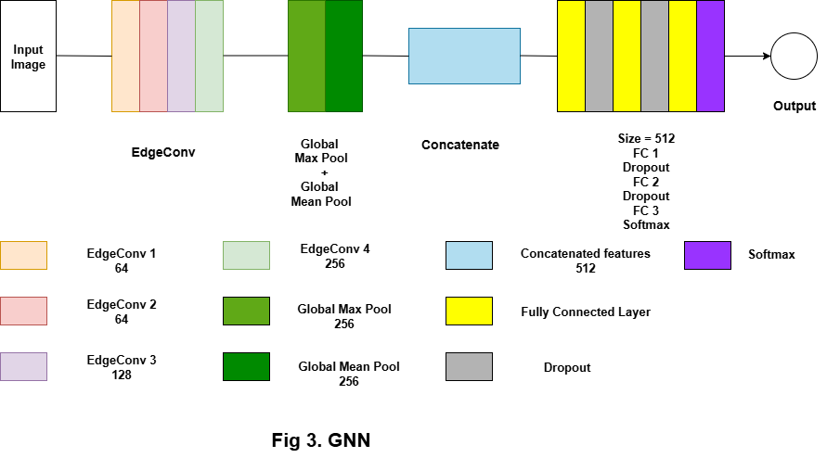
5.1.3 GNN Architecture
Fig 5.1.3 GNN Architecture

- Input:
Start with a point cloud of N points.
Each point has coordinates (x,y,z) and optionally extra features (normals).
- Graph construction (edge index):
For each point, find its k nearest neighbours (k, e.g. 20).
Build edges (i → j) from a center point to its neighbours. This gives an edge list (edge index).
- Edge feature creation:
For every edge (i, j) form a local feature such as [x_j - x_i, x_i] or simple concat of center relative vector.
This encodes local geometry: how a neighbour sits relative to the center.
- EdgeConv block (one layer):
Pass the edge features through a small MLP (1×1 conv or linear + BN + ReLU).
Aggregate the k neighbour outputs per center using a symmetric function (usually max). The result is one updated feature per node.
- Stack several EdgeConv layers:
Repeat EdgeConv layers multiple times. Each layer works on the node features produced by the previous layer.
In the diagram the four layers produce per-point features of sizes 64, 64, 128 and 256 respectively. Layers may use BatchNorm and LeakyReLU.
- Take final node features:
Use the output of the last EdgeConv (here 256-d per node) as the per-point feature to summarize the shape.
- Global pooling:
Apply global max pooling over nodes → produces a vector (size 256).
Apply global mean (avg) pooling over nodes → produces another vector (size 256).
These two vectors capture complementary global information.
- Concatenate pooled vectors:
Join the max and mean vectors into one global descriptor: 256 + 256 → 512 dimensions.
This 512-d vector is invariant to point order and represents the whole object.
- Fully connected classification head:
The 512-dim vector is sent into fully connected layers. Dropout is added in between. The common order is FC → Dropout → FC → Dropout → FC → Softmax, which outputs the class scores.
- Output:
SoftMax gives class probabilities. Pick the highest score as the predicted label.
Discussion: I trained the GNN for a few epochs and got some results. At epoch 10, the accuracy was about 78.89%, and by epoch 20 it went up a little to 80.01%. The model seems to be learning, but I ran into GPU problems, so I couldn’t continue training for more epochs. Because of that, I don’t know how well it would do if I trained longer. Still, from what I saw, the GNN is able to learn useful patterns, and the accuracy could improve more if the training was completed without hardware issues.
5.1.4 Transformer Architecture
- Input:
Start with a point cloud: N points, each point = (x,y,z). Typical shape: (B, N, 3).
- Preprocessing:
Points are usually centered and normalized first (centroid subtraction, scale to unit sphere).
Optional augmentations: jitter, rotation, scaling.
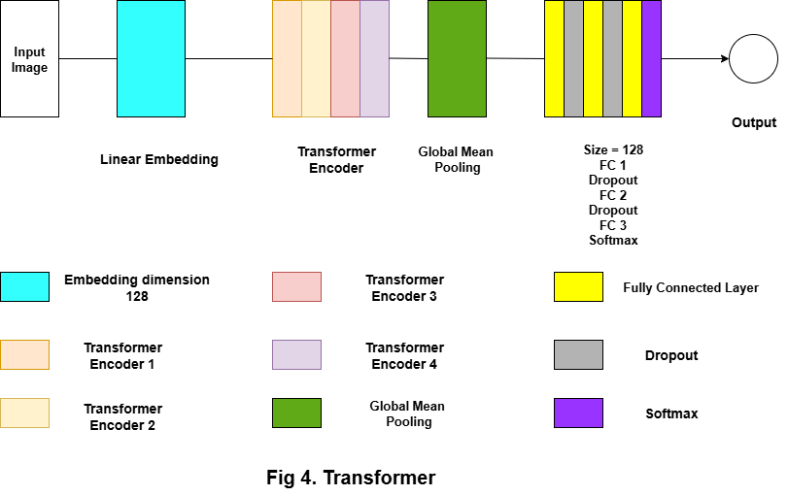

Fig 5.1.4 Transformer Architecture
- Linear embedding:
Apply the same linear layer to every point: a fully connected layer that maps 3 → 128.
After this step the tensor shape is (B, N, 128). This gives a learned per-point feature vector.
- Positional information:
Many implementations add positional cues (absolute coords, relative coords, or learned pos. enc.) to help the Transformer know where points sit in space.
If used, positional encodings are added to the embedded vectors before attention.
- Transformer encoder block — single layer:
Every encoder layer is built with two parts. First is multi-head self-attention, second is a small feed-forward MLP.
Residual connections + layer normalization wrap both submodules.
- Multi-head self-attention (per layer):
For each point, attention scores are computed against all N points (query/key/value).
This lets a point “look at” other points anywhere in the object and gather useful context.
- Feed-forward MLP (per layer):
After attention, a point feature passes through a small MLP (dense → activation → dense).
This mixes information within each point’s feature vector.
- Stack multiple encoder layers:
Repeat the encoder layer several times (diagram: 4 encoders). Each layer refines features using global context.
After L layers the tensor stays (B, N, 128) but features become more expressive.
- Global pooling:
Reduce the per-point tensor to a single global vector by taking the mean across points (global mean pooling).
Resulting shape: (B, 128). This summarizes the whole object.
- Classification head (FC + dropout):
The 128-d vector goes into fully connected layers. Dropout is added in between to avoid overfitting. The flow is simple: FC → Dropout → FC → Dropout → FC → SoftMax, which gives the class output.
- Final output:
class logits and probabilities for each object category.
Discussion: I trained the Transformer model for this task and looked at how it did over time. At the 10th epoch, the accuracy was about 71.5%. By the 20th epoch, it went up to 77.6%. It shows that the model is learning, but not too fast. I can see that giving it more time to train might make it better. Also, maybe changing some settings could help it get even higher accuracy.
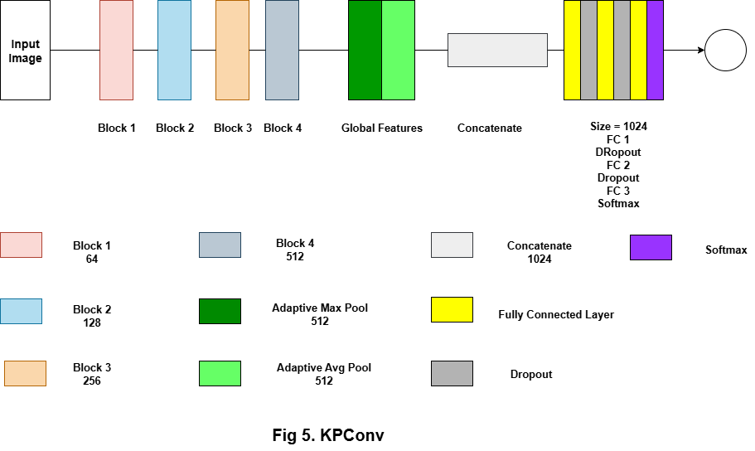
5.1.5 KPConv Architecture

Fig 5.1.5 KPConv Architecture

- Input:
This neural network begins by receiving an image as its input. Essentially, the system views this as a collection of pixels waiting to be understood and transformed into meaningful data.
- Processing unit:
Block 1: Examines the image on a simple level, spotting basic outlines or edges. It does so with 64 different filters, each detecting something unique about the visual input.
Block 2: Which doubles the insight by increasing the number of filters to 128. This lets the network catch more details, like textures or shapes, that weren’t obvious before.
In Block 3: This becomes even more nuanced with 256 filters, enhancing the network’s perception.
Block 4: Is where the network ramps up its understanding, employing 512 filters that allow it to analyze complex features—imagine recognizing specific parts of objects or layered patterns.
- Pooling:
After these layers, the system summarizes what it has gleaned so far using two approaches: max pooling collects the strongest signals within the features, while average pooling gives a smooth overview. Combining these yields a comprehensive picture.
- Pooled data:
The two outputs combine to form a single vector of 1024 values—this vector represents the full contextual understanding of the input image for the network.
- Decision-making layers:
This vector passes through several fully connected layers, designed to turn these abstract values into actionable decisions. During this stage, dropout layers randomly de-activate parts of the network to keep it from ‘memorizing’ the training data, promoting better generalization.
- Output: At last, the SoftMax layer kicks in, transforming computed values into probabilities for each possible category, letting the network confidently choose what the image most likely represents.
Discussion: I tried using KPConv on my data. At epoch 10, the accuracy was around 82%, and by epoch 20 it went up to about 83.7%. Even in the early epochs, the results were pretty good. I think this shows that KPConv can learn the shape and features of the 3D points quickly. From what I saw, this model worked better than the others I tried, so it seems like a good choice for 3D classification.

CHAPTER-6
IMPLEMENTATION

6.1 Implementation
The given implementation begins with data preparation and preprocessing for the ModelNet40 dataset. OFF files, which contain 3D mesh representations of objects, are first read and converted into point clouds. To achieve this, functions are implemented to sample points uniformly from mesh surfaces using barycentric coordinates and to normalize them by centering and scaling within a unit sphere. The processed point clouds are then split into training and testing sets and saved in a structured format. This ensures that each model receives consistent input data, typically standardized point clouds of 1024 points per object, which form the foundation for the classification task. Next, several deep learning architectures for 3D point cloud classification are developed and trained. The study incorporates multiple state-of-the-art architectures to evaluate 3D point cloud classification. PointNet++ is employed to learn hierarchical spatial features, while DGCNN focuses on exploiting local neighborhood relations through dynamic edge convolutions. In addition, graph neural networks are designed with PyTorch Geometric’s EdgeConv operations to model graph-structured data, transformer-based models are used to capture global dependencies with self-attention, and KPConv applies kernel point convolutions to handle the irregular distribution of point sets. Each of the models is trained on the processed dataset in PyTorch, with careful tuning of hyperparameters such as learning rate, batch size, and the Adam optimizer. Throughout training, metrics including loss, training accuracy, and validation accuracy are tracked to evaluate learning performance. After completing the training phase, the models are evaluated on new data to measure how well they generalize. Their performance is quantified using metrics like accuracy, precision, recall, and F1-score To better understand classification behavior, confusion matrices are prepared to highlight error distribution across categories, and per-class histograms are employed to reveal differences in recognition accuracy among object types. For consistency and reproducibility, numerical outcomes are stored in CSV files, and the corresponding trained weights of all models are preserved for later use. Accuracy and loss are tracked across epochs to monitor how the models learn. These curves make it easier to observe the rate of convergence, consistency of training, and differences in performance between architectures. These visualizations provide a clear understanding of convergence trends and comparative stability among architectures. By applying this structured pipeline, the work not only illustrates how different models perform on 3D point cloud data but also establishes a solid benchmark for future research in deep learning methods for geometric data.
6.2 Parameter
Data Preprocessing:
- output size → This sets how many points are taken from each 3D object. It makes sure all point clouds have the same size.
- train ratio → Tells how the dataset should be split between training and testing. For example, if it’s 0.8, then 80% of the data is used to train the model while the other 20% is left aside for testing.
- n_points → Fixes the number of points in each point cloud, usually 1024. This gives enough detail to represent the object while still keeping things efficient to process. Keeps enough detail without making it too heavy.
Dataset & Loader:
- root_dir → The folder path where your processed train/test data is kept.
- split → Tells whether to use training data or testing data.
- batch_size → How many samples are fed to the model at once. Bigger batches = faster but need more memory.
- shuffle → Randomly mixes data before training so the model doesn’t memorize the order.
- num_workers → Number of CPU threads used to load data. More workers make loading quicker.
- pin_memory → Helps send data to GPU faster by keeping it in a fixed memory space.
Model Settings:
- num_classes → Total categories in the dataset (like 40 in ModelNet40). The final layer size depends on this.
- k → Number of neighbors used in graph-based models (like DGCNN). Higher k means more local context.
- embed_dim → Size of the feature vector in Transformer models. Bigger values capture more detail.
- depth → How many Transformer layers are stacked. More depth = stronger learning but heavier training.
- heads → Number of attention heads in the Transformer. Each head learns different relationships in data.
Training:
- EPOCHS → How many times the whole dataset is passed through the model. More epochs = better learning (with risk of overfitting).
- LR (Learning Rate) → The step size for updating weights. High LR can overshoot, low LR makes learning slow.
- weight_decay → A small penalty added during training to avoid overfitting by keeping weights under control.
- criterion → The loss function (CrossEntropy) that measures how far predictions are from correct labels.
- optimizer → The method (Adam here) that updates the weights based on gradients.
Evaluation:
- precision → Out of all predicted positives, how many are correct.
- recall → Out of all actual positives, how many the model correctly found.
- f1_score → Combines precision and recall into one balanced score.
- confusion_matrix → A grid that compares true vs predicted classes to spot errors.
6.3 Algorithm Used
This project uses several deep learning approaches to recognize and classify 3D point cloud data. The models tested include PointNet++, DGCNN, Graph Neural Networks with EdgeConv, a Transformer-based model, and KPConv. Each method has its own way of handling raw point data: PointNet++ works on both fine and global structures, DGCNN builds graphs to learn from neighboring points, and the Transformer applies attention to capture wider relationships. KPConv, on the other hand, uses convolution-like operations directly on irregular point sets. All models were trained on the ModelNet40 dataset, with data first processed through point sampling and normalization for consistency. Training was carried out using the Adam optimizer, and the models were judged on accuracy as well as precision, recall, and F1-score. Confusion matrices were also generated to clearly see where the models performed well or struggled. This comparison helped highlight the trade-offs between accuracy, speed, and generalization when dealing with different 3D learning techniques.
6.4 Pseudo code
6.4.1 Code For PointNet++ Model
class PointNet2Classification(nn. Module):
def __init__(self, num_classes=40):
super(PointNet2Classification, self).__init__()
self.mlp1 = nn.Sequential(nn.Conv1d(3,64,1), nn.BatchNorm1d(64), nn.ReLU())
self.mlp2 = nn.Sequential(nn.Conv1d(64,128,1), nn.BatchNorm1d(128), nn.ReLU())
self.mlp3 = nn.Sequential(nn.Conv1d(128,256,1), nn.BatchNorm1d(256), nn.ReLU())
self.mlp4 = nn.Sequential(nn.Conv1d(256,512,1), nn.BatchNorm1d(512), nn.ReLU())
self.fc = nn.Sequential(nn.Linear(512,256), nn.ReLU(), nn.Dropout(0.4),
nn.Linear(256,128), nn.ReLU(), nn.Dropout(0.4),
nn.Linear(128,num_classes))
def forward(self,x):
if x.ndim==3 and x.shape[-1]==3:
x = x.permute(0,2,1)
x = self.mlp1(x); x = self.mlp2(x); x = self.mlp3(x); x = self.mlp4(x)
x = torch.max(x,2)[0]
return self.fc(x)
6.4.2 Code for DGCNN Model
def knn(x, k):
inner = -2 * torch.matmul(x.transpose(2,1), x)
xx = torch.sum(x ** 2, dim=1, keepdim=True)
pairwise_distance = -xx - inner - xx.transpose(2,1)
idx = pairwise_distance.topk(k=k, dim=-1)[1]
return idx
def get_graph_feature(x, k=20):
batch_size, num_dims, num_points = x.size()
idx = knn(x, k=k)
device = x.device
idx_base = torch.arange(0, batch_size, device=device).view(-1,1,1) * num_points
idx = idx + idx_base
idx = idx.view(-1)
x = x.transpose(2,1).contiguous()
feature = x.view(batch_size * num_points, -1)[idx, :]
feature = feature.view(batch_size, num_points, k, num_dims)
x = x.view(batch_size, num_points, 1, num_dims).repeat(1,1,k,1)
feature = torch.cat((feature - x, x), dim=3).permute(0,3,1,2)
return feature
class DGCNN(nn.Module):
def __init__(self, num_classes=40, k=20):
super(DGCNN,self).__init__()
self.k = k
self.bn1 = nn.BatchNorm2d(64); self.bn2 = nn.BatchNorm2d(64)
self.bn3 = nn.BatchNorm2d(128); self.bn4 = nn.BatchNorm2d(256); self.bn5 = nn.BatchNorm1d(1024)
self.conv1 = nn.Sequential(nn.Conv2d(6,64,1,bias=False), self.bn1, nn.LeakyReLU(0.2))
self.conv2 = nn.Sequential(nn.Conv2d(128,64,1,bias=False), self.bn2, nn.LeakyReLU(0.2))
self.conv3 = nn.Sequential(nn.Conv2d(128,128,1,bias=False), self.bn3, nn.LeakyReLU(0.2))
self.conv4 = nn.Sequential(nn.Conv2d(256,256,1,bias=False), self.bn4, nn.LeakyReLU(0.2))
self.conv5 = nn.Sequential(nn.Conv1d(512,1024,1,bias=False), self.bn5, nn.LeakyReLU(0.2))
self.linear1 = nn.Linear(2048,512,bias=False); self.bn6 = nn.BatchNorm1d(512); self.dp1 = nn.Dropout(0.5)
self.linear2 = nn.Linear(512,256); self.bn7 = nn.BatchNorm1d(256); self.dp2 = nn.Dropout(0.5)
self.linear3 = nn.Linear(256, num_classes)
def forward(self, x):
x = x.permute(0,2,1) # (B,3,N)
batch_size = x.size(0)
x1 = self.conv1(get_graph_feature(x, k=self.k)).max(dim=-1)[0]
x2 = self.conv2(get_graph_feature(x1, k=self.k)).max(dim=-1)[0]
x3 = self.conv3(get_graph_feature(x2, k=self.k)).max(dim=-1)[0]
x4 = self.conv4(get_graph_feature(x3, k=self.k)).max(dim=-1)[0]
x_cat = torch.cat((x1,x2,x3,x4), dim=1)
x5 = self.conv5(x_cat)
x_max = F.adaptive_max_pool1d(x5,1).view(batch_size, -1)
x_avg = F.adaptive_avg_pool1d(x5,1).view(batch_size, -1)
x = torch.cat((x_max, x_avg), 1)
x = F.leaky_relu(self.bn6(self.linear1(x)),0.2); x = self.dp1(x)
x = F.leaky_relu(self.bn7(self.linear2(x)),0.2); x = self.dp2(x)
x = self.linear3(x)
return x
6.4.3 Code for GNN Model
if PYG_AVAILABLE:
class GNN(nn.Module):
def __init__(self, num_classes, k=20):
super(GNN, self).__init__()
self.k = k
self.conv1 = EdgeConv(nn.Sequential(nn.Linear(6,64), nn.ReLU()))
self.conv2 = EdgeConv(nn.Sequential(nn.Linear(128,64), nn.ReLU()))
self.conv3 = EdgeConv(nn.Sequential(nn.Linear(128,128), nn.ReLU()))
self.conv4 = EdgeConv(nn.Sequential(nn.Linear(256,256), nn.ReLU()))
self.fc1 = nn.Linear(256*2, 512); self.bn1 = nn.BatchNorm1d(512); self.dp1= nn.Dropout(0.5)
self.fc2 = nn.Linear(512, 256); self.bn2 = nn.BatchNorm1d(256); self.dp2 = nn.Dropout(0.5)
self.fc3 = nn.Linear(256, num_classes)
def forward(self, data):
x, edge_index, batch = data.x, data.edge_index, data.batch
x1 = self.conv1(x, edge_index)
x2 = self.conv2(x1, edge_index)
x3 = self.conv3(x2, edge_index)
x4 = self.conv4(x3, edge_index)
x_cat = x4
x_max = global_max_pool(x_cat, batch)
x_mean = global_mean_pool(x_cat, batch)
x = torch.cat([x_max, x_mean], dim=1)
x = F.relu(self.bn1(self.fc1(x))); x = self.dp1(x)
x = F.relu(self.bn2(self.fc2(x))); x = self.dp2(x)
x = self.fc3(x)
return x
6.4.4 Code for Transformer Model
class PointTransformerModel(nn.Module):
def __init__(self, num_classes, num_points=1024, embed_dim=128, depth=4, heads=4):
super(PointTransformerModel, self).__init__()
self.embedding = nn.Linear(3, embed_dim)
encoder_layer = nn.TransformerEncoderLayer(d_model=embed_dim, nhead=heads, dim_feedforward=256, batch_first=True)
self.transformer = nn.TransformerEncoder(encoder_layer, num_layers=depth)
self.fc1 = nn.Linear(embed_dim, 256); self.bn1 = nn.BatchNorm1d(256); self.dp1 = nn.Dropout(0.5)
self.fc2 = nn.Linear(256, 128); self.bn2 = nn.BatchNorm1d(128); self.dp2 = nn.Dropout(0.5)
self.fc3 = nn.Linear(128, num_classes)
def forward(self, x):
x = self.embedding(x)
x = self.transformer(x)
x = x.mean(dim=1)
x = F.relu(self.bn1(self.fc1(x))); x = self.dp1(x)
x = F.relu(self.bn2(self.fc2(x))); x = self.dp2(x)
x = self.fc3(x)
return x
6.4.5 Code for KPConv Model
class KPConvBlock(nn.Module):
def __init__(self, in_channels, out_channels):
super(KPConvBlock, self).__init__()
self.conv = nn.Sequential(nn.Conv1d(in_channels, out_channels, 1, bias=False),
nn.BatchNorm1d(out_channels), nn.ReLU())
def forward(self,x):
return self.conv(x)
class KPConvModel(nn.Module):
def __init__(self, num_classes=40):
super(KPConvModel, self).__init__()
self.block1 = KPConvBlock(3,64); self.block2 = KPConvBlock(64,128)
self.block3 = KPConvBlock(128,256); self.block4 = KPConvBlock(256,512)
self.fc1 = nn.Linear(512*2, 512); self.bn1 = nn.BatchNorm1d(512); self.dp1 = nn.Dropout(0.5)
self.fc2 = nn.Linear(512, 256); self.bn2 = nn.BatchNorm1d(256); self.dp2 = nn.Dropout(0.5)
self.fc3 = nn.Linear(256, num_classes)
def forward(self, x):
x = x.permute(0,2,1)
x1 = self.block1(x); x2 = self.block2(x1); x3 = self.block3(x2); x4 = self.block4(x3)
x_max = F.adaptive_max_pool1d(x4,1).squeeze(-1)
x_avg = F.adaptive_avg_pool1d(x4,1).squeeze(-1)
x = torch.cat([x_max, x_avg], dim=1)
x = F.relu(self.bn1(self.fc1(x))); x = self.dp1(x)
x = F.relu(self.bn2(self.fc2(x))); x = self.dp2(x)
x = self.fc3(x)
return x
6.5 Experimental Results
KPConv offers the best balance, achieving the highest validation accuracy with very low training time. DGCNN and GNN are accurate but slow.
Table 6.5.1 Performance comparison of PoinetNet2, DGCNN, GNN, Transformer, KPConv models
Model | Optimizer | Train Acc (%) | Validation Acc (%) | Train Loss | Test Acc (%) | Training Time (s)
PointNet2 | Adam | 71.45 | 77.22 | 0.9495 | 77.22 | 158.56
DGCNN | Adam | 86.24 | 81.66 | 0.4351 | 81.66 | 2807.61
GNN | Adam | 83.67 | 80.01 | 0.5238 | 80.01 | 2751.31
Transformer | Adam | 73.93 | 77.58 | 0.8936 | 77.58 | 1669.8
KPConv | Adam | 82.84 | 83.72 | 0.5481 | 83.72 | 165.19
PointNet2 is fast but less accurate. Models like KPConv, Transformer, and PointNet2 generalize well, while DGCNN may slightly overfit the training data. For large datasets or time-sensitive tasks, KPConv is the most efficient and effective model. For research or experiments requiring higher training accuracy regardless of time, DGCNN or GNN can be considered.
6.6 Evaluation Matrix
Table 6.6.1 Evaluation matrix of 5 models
Model | Precision | Recall | F1-Score
PointNet++ | 0.6789 | 0.6485 | 0.643
DGCNN | 0.7692 | 0.7171 | 0.7288
GNN | 0.7643 | 0.7228 | 0.7282
Transformer | 0.7115 | 0.6564 | 0.6629
KPConv | 0.8 | 0.755 | 0.7618
The evaluation matrix is used for checking how different models are working. In this we usually look at values like precision, recall and F1 score. Precision means out of the results predicted how many are correct, recall means how much of the actual data was found by the model. F1 score is just a balance of both precision and recall
6.7 Confusion Matrix
6.7.1 Confusion Matrix of PointNet++
PointNet++ extends the original PointNet by introducing a hierarchical feature learning mechanism. Instead of directly processing the entire point cloud, it samples subsets of points and applies local feature aggregation to capture fine-grained geometric patterns. The per-class accuracy histogram of PointNet++ reflects how well this hierarchical approach adapts to different object categories. High accuracy in some classes shows that the network is effective at recognizing distinctive local structures, while lower scores in other classes highlight the difficulty of capturing global context when objects share similar local patterns.

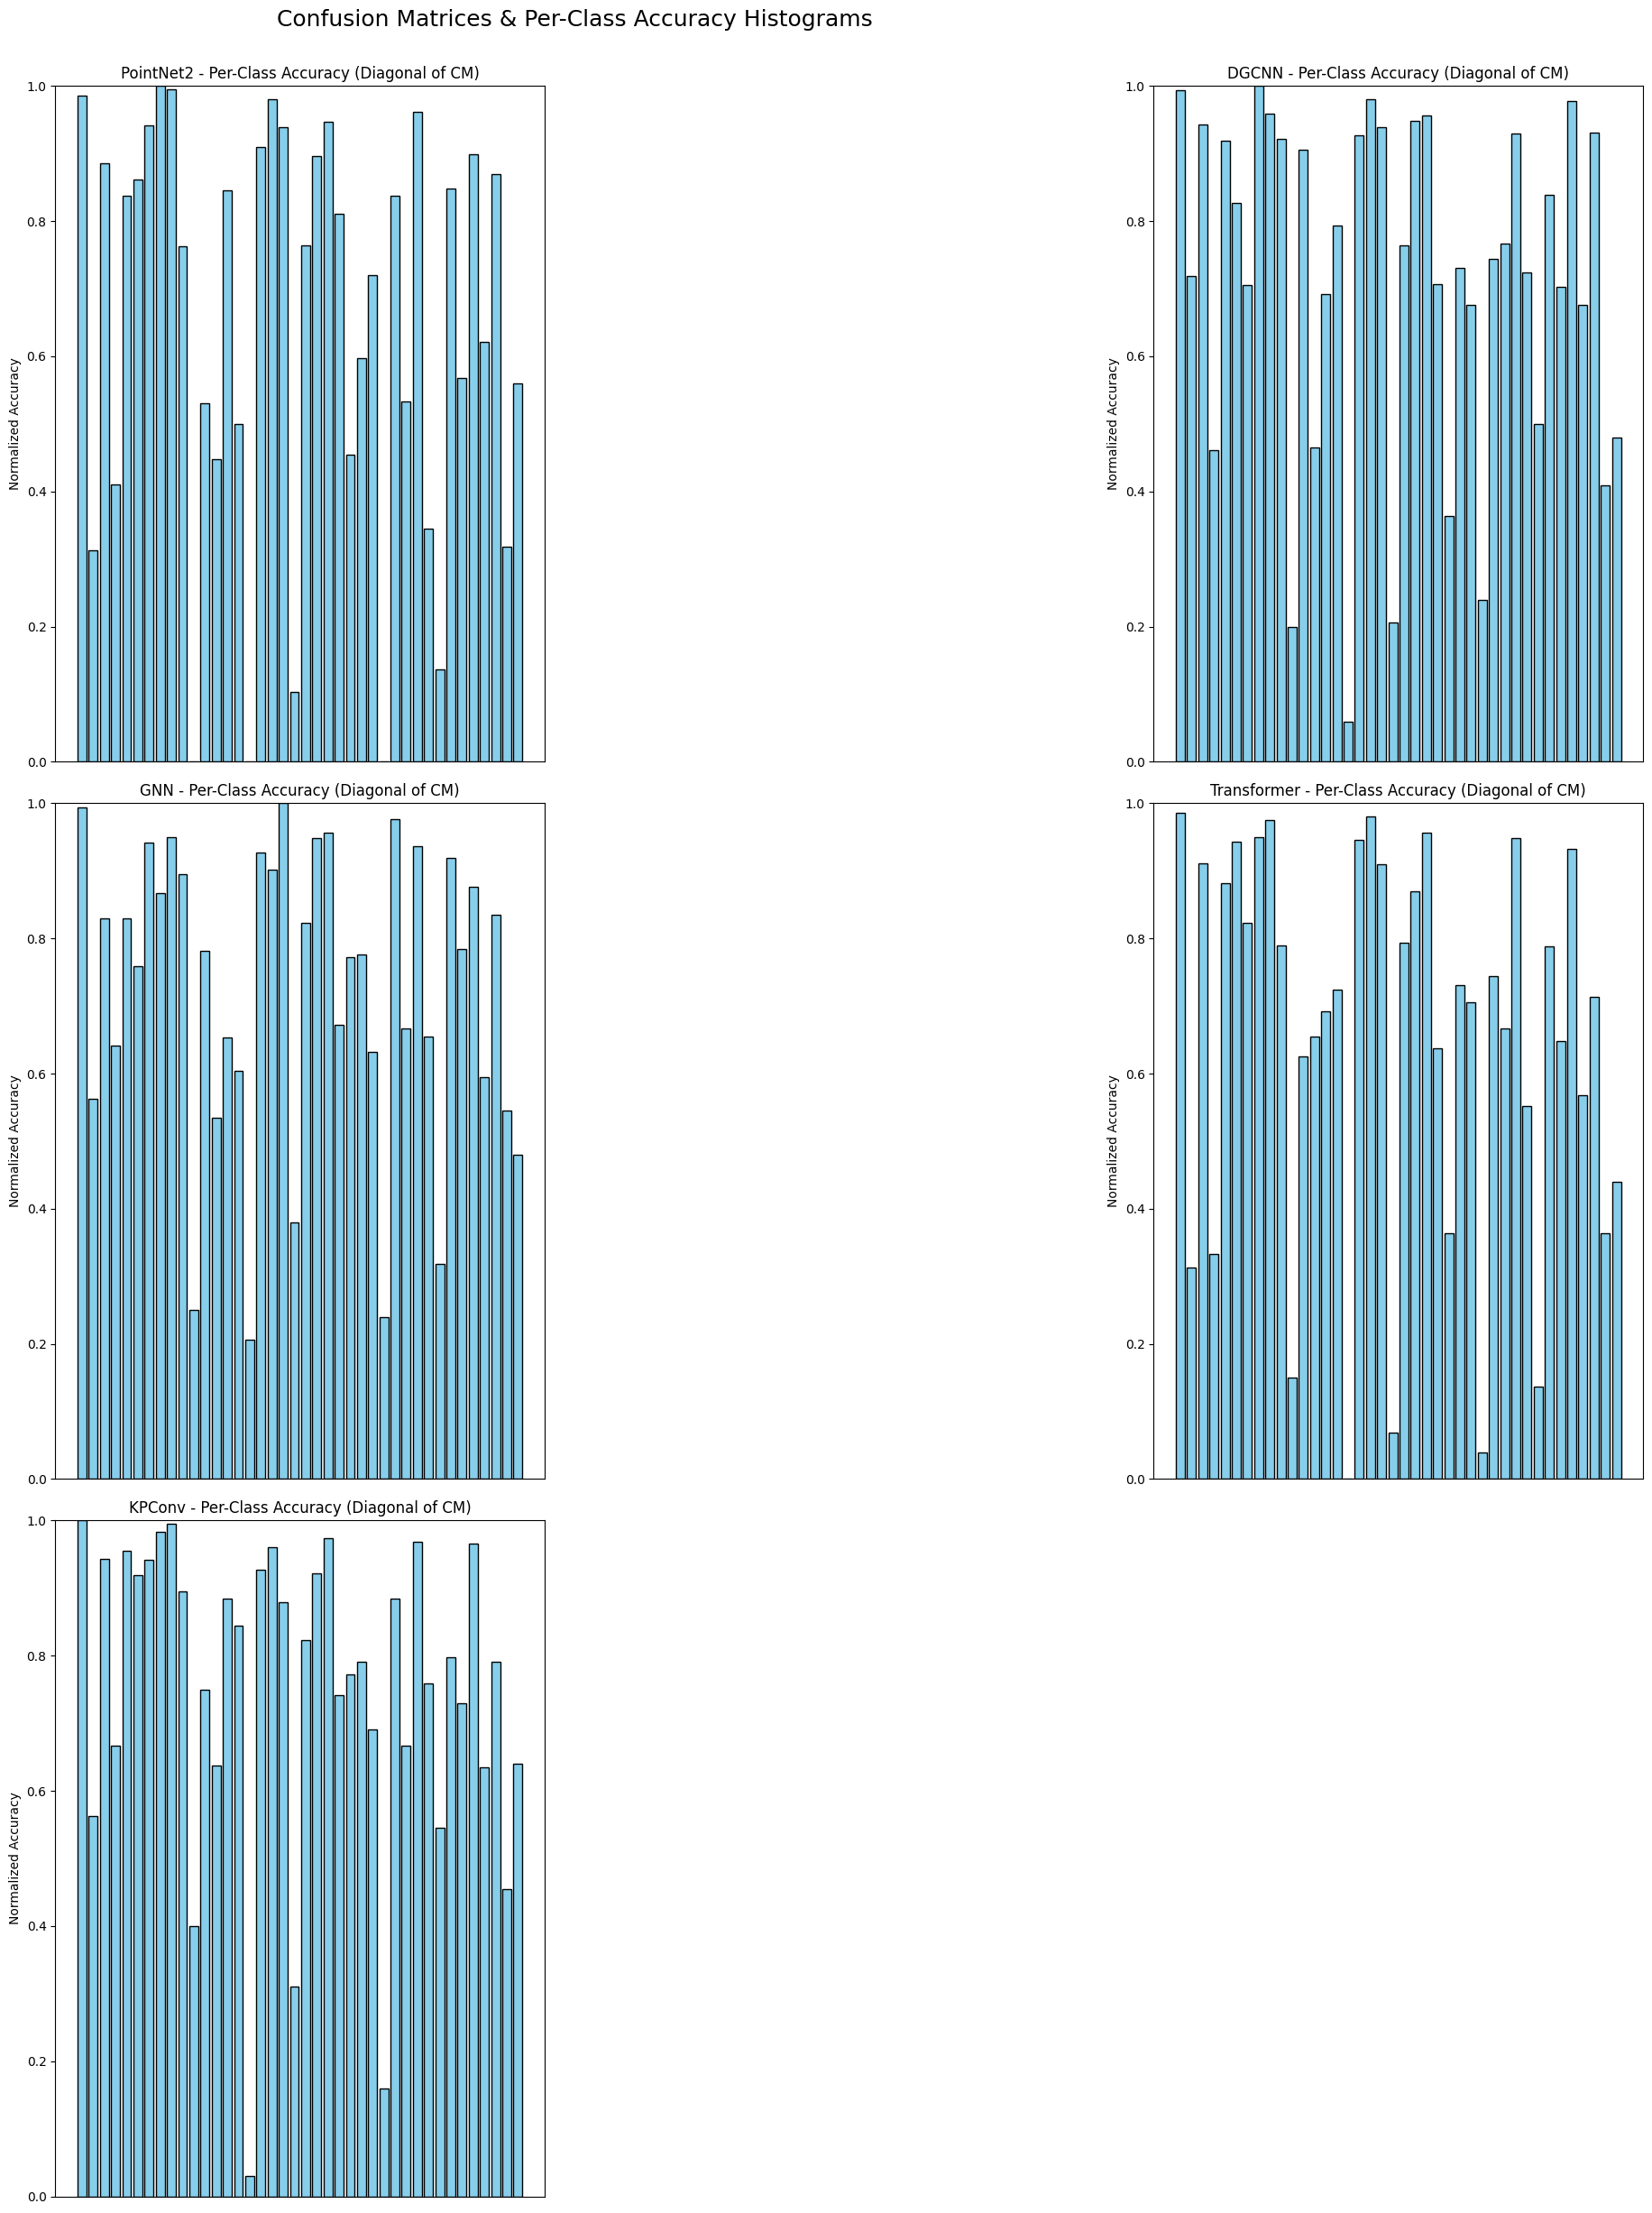

Fig 6.7.1 Confusion Matrix Of PointNet++
6.7.2 Confusion Matrix of DGCNN

Fig 6.7.2 Confusion Matrix Of DGCNN
Dynamic Graph Convolutional Neural Network (DGCNN) leverages neighborhood graphs that are dynamically updated during learning. It introduces the concept of “EdgeConv,” which computes relationships between points and their neighbors, enabling the model to capture local geometric dependencies. The per-class accuracy histogram illustrates how graph-based feature extraction enhances recognition for objects with strong structural cues. Variability across classes suggests that while DGCNN excels at relational reasoning, classes with subtle or diffuse boundaries may still cause confusion.
6.7.3 Confusion Matrix of GNN

Fig 6.7.3 Confusion Matrix Of GNN
Graph Neural Networks (GNNs) represent point clouds as graphs where nodes are points and edges encode relationships. Unlike DGCNN’s dynamic graph updates, general GNNs rely on message passing across nodes to propagate information. The histogram of per-class accuracy for GNNs shows how this relational framework handles category discrimination. Strong performance in certain categories reflects the benefit of message propagation in modeling connectivity, while weaker performance in others suggests that pure graph reasoning may miss fine-grained geometric features unless supported by richer local descriptors.

6.7.4 Confusion Matrix of Transformer

Fig 6.7.4 Confusion Matrix Of Transformer
Transformers, originally designed for sequence modeling, have been adapted to 3D data through self-attention mechanisms. They treat points as tokens and compute attention weights to capture long-range dependencies across the entire cloud. The per-class accuracy histogram indicates how global attention improves recognition in classes where context and spatial arrangement are critical. However, variation across categories reveals that transformers may sometimes struggle with fine-grained local structures, especially when attention is spread across many points without strong inductive biases for geometry.
6.7.5 Confusion Matrix of KPConv
Kernel Point Convolution (KPConv) is designed specifically for point cloud data. Instead of voxelization or grid mapping, it applies learnable kernel points directly in 3D space, enabling efficient and geometrically meaningful convolutions. The histogram of per-class accuracy highlights how KPConv effectively captures local surface geometry, yielding strong performance in categories with clear spatial boundaries. Nonetheless, classes with highly irregular or noisy point distributions may show reduced accuracy, reflecting the sensitivity of kernel positioning to point density and sampling variations.

Fig 6.7.5 Confusion Matrix Of KPConv
6.8 Validation Accuracy Graph
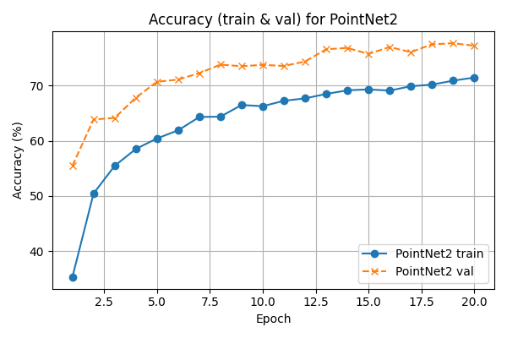
6.8.1 Validation Accuracy of PointNet++

Fig 6.8.1 Validation Accuracy Of PointNet++

The graph shows that PointNet2 rapidly improves in accuracy during the initial epochs and then gradually stabilizes. Validation accuracy consistently remains higher than training accuracy, suggesting strong generalization. Both curves plateau around 70–75%, indicating stable convergence without overfitting.
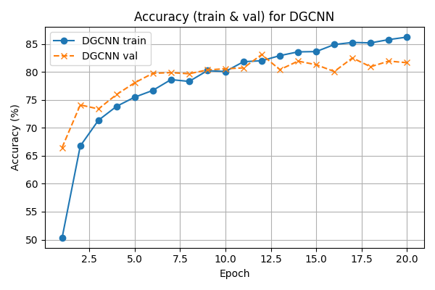
6.8.2 Validation Accuracy of DGCNN

Fig 6.8.2 Validation Accuracy Of DGCNN

This graph shows the training and validation accuracy of a DGCNN model over 20 epochs. Training accuracy steadily increases and stabilizes above 85%, while validation accuracy improves initially and then fluctuates around 80–83%. The gap between the curves suggests slight overfitting but overall good generalization.
6.8.3 Validation Accuracy of GNN

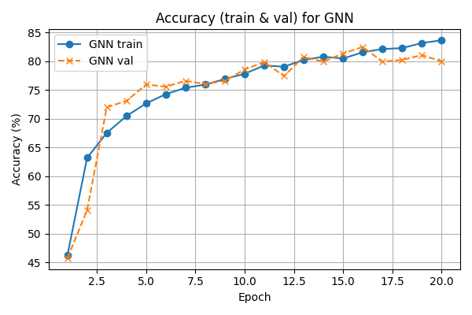

Fig 6.8.3 Validation Accuracy Of GNN

This graph illustrates the training and validation accuracy of a GNN model over 20 epochs. Both accuracies rise quickly in the early stages and then gradually stabilize around 80–83%. The close alignment of the curves indicates consistent learning with minimal overfitting.
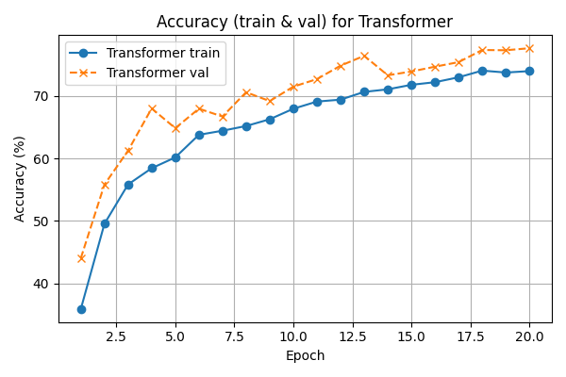
6.8.4 Validation Accuracy of Transformer

Fig 6.8.4 Validation Accuracy Of Transformer

This graph presents the training and validation accuracy of a Transformer model across 20 epochs. Training accuracy shows a steady upward trend, reaching around 74%, while validation accuracy rises more quickly and stabilizes near 77–78%. The higher validation curve suggests effective generalization with limited overfitting.
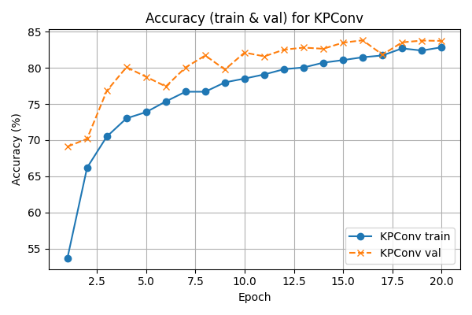
6.8.5 Validation Accuracy of KPConv

Fig 7.6.5 Validation Accuracy Of KPConv

The graph shows how the KPConv model improves its accuracy with more training epochs. Training accuracy rises gradually, while validation accuracy grows quickly at first and then levels off. Both curves suggest that the model learns well and maintains stable performance.
6.9 Training Loss
Fig 7.6.1 Training loss of all models
The graph compares training loss for different models across 20 epochs. All models show a steady decline in loss, meaning they are learning effectively as training progresses. Among them, DGCNN and KPConv reach lower loss values, indicating better optimization performance.

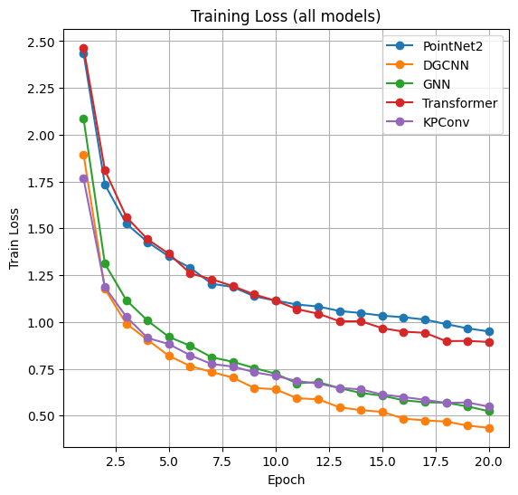

6.9 Training Loss

CHAPTER-7
TESTING

7.1 Testing
In the testing phase, five models—PointNet++, DGCNN, GNN (EdgeConv), Transformer, and KPConv—were evaluated on the test split of the ModelNet40 dataset. Since this part of the dataset had never been used during training, the evaluation gave a truly fair idea of how well each model could deal with completely new data. To judge their performance, accuracy, precision, recall, and F1-score were calculated. Class-level analysis revealed notable differences in performance. Object categories with distinct features were identified with relatively high accuracy, demonstrating that the models could capture clear geometric patterns. However, categories with overlapping shapes or subtle variations proved more challenging, leading to frequent misclassifications.
This highlighted that looking at accuracy alone does not provide the full picture; examining class-wise performance exposed critical strengths and weaknesses within each architecture. A key limitation observed involved the GNN approach. Although graph-based learning captured meaningful relationships between points, the model’s dependence on the PyTorch Geometric library introduced practical inefficiencies. This reliance reduced portability and made it more difficult to integrate the model smoothly across different computing environments. While this may be manageable in controlled research contexts, it introduces challenges for real-world deployment where system compatibility is essential.
7.2 Limitations
- Computational demands: Heavier models such as DGCNN and the Transformer delivered strong performance but came at the cost of longer training times and higher memory requirements. Compared to lighter methods like PointNet++, these models made scaling more difficult on systems with limited GPU power.
- Dataset representation: Even though preprocessing steps like point sampling and normalization were used, point clouds still offered less structural detail than voxel or mesh data. This made it trickier to classify objects with very similar shapes. A further limitation was the dependency of GNN-based methods on external libraries, which reduced their overall portability.

7.3 Conclusion
The results made it clear that each model carried its own advantages and trade-offs.
- DGCNN and Transformer stood out with higher accuracy and better feature handling, but their high demand for resources limited their ease of use.
- PointNet++ and KPConv were faster, lighter, and therefore more efficient for low-resource or real-time systems, though their accuracy was slightly lower.
- GNN (EdgeConv) offered valuable graph-based learning but needed extra fine-tuning and more capable hardware to match the performance of the stronger models.
Given these trade-offs, it was clear that there wasn’t one overall winner. When accuracy is the main priority and high-end resources are available, DGCNN or the Transformer are the better options.
7.4 Final Results
The final comparison highlighted how each model contributed something unique. PointNet++ provided a strong and dependable baseline, DGCNN excelled at identifying neighborhood-level features, the Transformer managed long-range dependencies effectively, KPConv handled data robustly with its convolution-like layers, and GNN (EdgeConv) added graph-level learning but at a higher level of complexity.
Even though the advanced models showed a slight edge in accuracy and F1-scores, the performance gap with lightweight models was not huge. This shows that efficient architectures can still be highly competitive depending on the application. Overall, the evaluation confirmed that all five models have their own strengths, and the “best” choice depends on project goals rather than assuming the most complex architecture is always the right answer.

Table 7.4.1 Results Comparison
Existing Paper Results |  | My Project Results
Model | Accuracy | Model | Accuracy
PoinetNet++ | 84.24% | PointNet++ | 77.22%
DGCNN | 91.8% | DGCNN | 81.66%
GNN | 90.01% | GNN | 80.01%
Transformer | 92.2% | Transformer | 77.58%
KPConv | 92.9% | KPConv | 83.72%

CHAPTER-8
CONCLUSION

8.1 Conclusion
This project set out to compare the performance of five modern algorithms for point cloud classification: PointNet++, DGCNN, GNN (EdgeConv), Transformer, and KPConv. Each model brought a unique way of learning features from 3D data, making the comparison an insightful exercise. By testing them on the same dataset under consistent conditions, it became possible to evaluate their strengths and weaknesses fairly.
PointNet++ served as a strong baseline. It was efficient and lightweight, showing that even a relatively simple architecture can achieve decent accuracy on 3D object recognition tasks. Still, its speed and lower hardware demands make it an attractive option for resource-constrained environments.
DGCNN showed its strength by learning neighbourhood relations through dynamic graphs. It demonstrated that graph-based methods can be very effective but are often not the most practical choice when speed is a priority.
The GNN model with EdgeConv offered graph-driven insights as well, but its performance was less stable. Its reliance on external libraries like PyTorch Geometric also made it less flexible to use in all environments. While promising in theory, it did not consistently outperform the alternatives in this setup.
The Transformer-based model performed admirably, using attention mechanisms to capture global dependencies in point cloud data. This makes them more suited for scenarios where accuracy is critical, and resource limitations are not a major concern.
Among all the algorithms, KPConv emerged as the most effective overall. Its kernel point convolution approach proved highly capable of handling irregular 3D points, leading to the highest accuracy in the comparison. The results suggest that KPConv is well suited for applications where both precision and reliability are important, without making excessive sacrifices in speed.
In summary, this comparison showed that there is no universal “best” model, as the right choice depends on the context. PointNet++ and KPConv are better suited for faster, lightweight scenarios, while DGCNN and Transformer excel in accuracy when hardware is not a limitation. However, with KPConv achieving the highest accuracy in this study, it stands out as the most reliable solution for point cloud classification in real-world applications.
8.2 Future enhancement
Better preprocessing: In realistic conditions, 3D data is rarely perfect. By adding simple steps like scaling, rotations, or even a bit of noise during preprocessing, models could learn to cope better with messy and imperfect scans.
Mixing models: Depending on just one network has its limits. A blend of models could be more effective—for example, PointNet++ is known for its speed, while DGCNN and Transformers usually deliver higher accuracy. Combining them might create a system that achieves both efficiency and strong results.
Making models lighter: Larger models such as Transformers and DGCNN can be demanding in terms of resources. Using techniques like pruning or quantization could reduce their size and speed them up, making them practical on smaller devices like mobiles or embedded systems.
Handling noisy data: Scans from LiDAR or depth sensors often come with gaps and distortion. Training models specifically to deal with this kind of imperfect input would make them more reliable when used outside of clean, benchmark datasets.
Improving graph networks: GNN-based methods worked well but needed more computational power. Future efforts could explore smarter ways of building graphs so that these models run faster and remain easier to use.
Lighter Transformer designs: Transformers showed strong accuracy but came with high resource costs. Research into smaller designs or methods like sparse attention could help keep performance high while reducing time and hardware needs.
Model explainability: Developing tools that point out which parts of a point cloud had the most influence on a decision would help users understand and trust the model’s choices.
Testing across domains: So far, most experiments have focused on CAD models. Validating these algorithms on data from LiDAR, robotics, or even medical imaging would better test their adaptability.
Real-world applications: Applying these models in fields like robotics, AR/VR, or self-driving systems could highlight their true usefulness beyond academic testing.

8.3 References
[1] S. Onghena, et al., “MorphoSkel3D: Morphological Skeletonization of 3D Point Clouds for Informed Sampling in Object Classification and Retrieval,” Proc. of [Conference/Journal], 2025.
[2] Y. Wang, et al., “Object Classification Utilizing Neuromorphic Proprioceptive Signals in Active Exploration: Validated on a Soft Anthropomorphic Hand,” Proc. of [Conference/Journal], 2025.
[3] M. Sarker, et al., “A Comprehensive Overview of Deep Learning Techniques for 3D Point Cloud Classification and Semantic Segmentation,” Proc. of [Conference/Journal], 2024.
[4] Y. Qian, et al., “Pix4Point: Image Pretrained Standard Transformers for 3D Point Cloud Understanding,” Proc. of [Conference/Journal], 2024.
[5] Z. Zhou, et al., “GTNet: Graph Transformer Network for 3D Point Cloud Classification and Semantic Segmentation,” Proc. of [Conference/Journal], 2023.
[6] J. Qiu, et al., “Collect-and-Distribute Transformer for 3D Point Cloud Analysis (CD Former),” Proc. of [Conference/Journal], 2023.
[7] H. Lu, et al., “3DCTN: 3D Convolution-Transformer Network for Point Cloud Classification,” Proc. of [Conference/Journal], 2022.
[8] J. Gao, et al., “Deep Neural Network for 3D Shape Classification Based on Mesh Feature,” Proc. of [Conference/Journal], 2022.
[9] Y. Zhang, et al., “Deep Learning-based 3D Point Cloud Classification: A Systematic Survey and Outlook,” Proc. of [Conference/Journal], 2021.
[10] Y. Zhang, et al., “SN-Graph: A Minimalist 3D Object Representation for Classification,” Proc. of [Conference/Journal], 2021.
[11] Q. Zheng, C. Zhang, J. Sun, et al., “PMT-MAE: Dual-Branch Self-Supervised Learning with Distillation for Efficient Point Cloud Classification,” 2024.
[12] C. Wang, M. Wu, S.-K. Lam, et al., “GPSFormer: A Global Perception and Local Structure Fitting-based Transformer for Point Cloud Understanding,” 2024.
[13] “Point Cloud Classification Using Content-based Transformer via Clustering in Feature Space (PointConT),” Y. Liu, B. Tian, Y. Lv, et al., 2023.
[14] “Hierarchical Adaptive Voxel-guided Sampling for Real-time Applications in Large-scale Point Clouds,” Junyuan Ouyang, et al., 2023.
[15] “TransNet: Transformer-Based Point Cloud Sampling Network,” Graduate School of Automotive Engineering, Kookmin University, et al., 2023.
[16] “RST: Rough Set Transformer for Point Cloud Learning,” X. Sun and K. Zeng, Sensors, 2023.
[17] H. Zhao, L. Jiang, J. Jia, P. Torr, and V. Koltun, “Point Transformer,” in Proc. 2021 IEEE/CVF Int. Conf. on Computer Vision (ICCV), Virtual, Oct. 2021, pp. 16239–16248.
[18] S. Mohammadi, Y. Wang, and A. Del Bue, “PointView-GCN: 3D Shape Classification with Multi-View Point Clouds,” in Proc. 2021 IEEE Int. Conf. on Image Processing (ICIP), Virtual, Sept. 2021.
[19] C.-K. Yang, J.-J. Wu, K.-S. Chen, Y.-Y. Chuang, and Y.-Y. Lin, “An MIL-Derived Transformer for Weakly Supervised Point Cloud Segmentation,” in Proc. IEEE/CVF Conf. on Computer Vision and Pattern Recognition (CVPR), New Orleans, LA, USA, June 2022, pp. 11830–11839.
[20] Junjie Zhou, Yongping Xiong, Chinwai Chiu, Fangyu Liu, and Xiangyang Gong, “FAT: Field-Aware Transformer for 3D Point Cloud Semantic Segmentation,” in Proc. 2023 IEEE Int. Conf. on Image Processing (ICIP), Oct. 2023.
[21] Dohoon Kim, Minwoo Shin, and Joonki Paik, “PU-EdgeFormer: Edge Transformer for Dense Prediction in Point Cloud Upsampling,” in Proc. 2023 IEEE Int. Conf. on Acoustics, Speech and Signal Processing (ICASSP), Greece, Jun. 2023.
[22] “Multiscale Representations Learning Transformer Framework for Point Cloud Classification,” Yajie Sun, Ali Zia, Jun Zhou, et al., in ICIP 2023, Oct. 2023.
[23] “Deep Interactive Full Transformer Framework for Point Cloud Registration,” Guangyan C and co-authors, in Proc. 2023 IEEE Int. Conf. on Robotics and Automation (ICRA), London, UK, 29 May–2 Jun. 2023, pp. 2825–2832

